Data Analysis

One.

select E.emp_no, E.last_name, E.first_name, E.sex, S.Salary

From Employees E

LEFT Join Salaries S

ON E.emp_no = S.emp_no

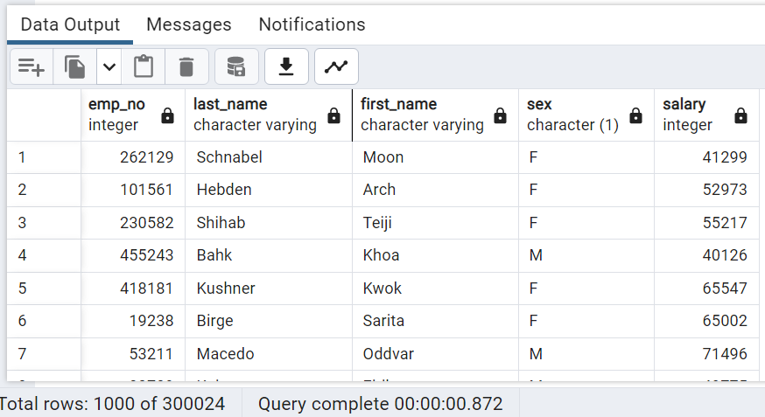

Two

SELECT first_name, last_name, hire_date

FROM employees

WHERE EXTRACT(YEAR FROM hire_date) = 1986;

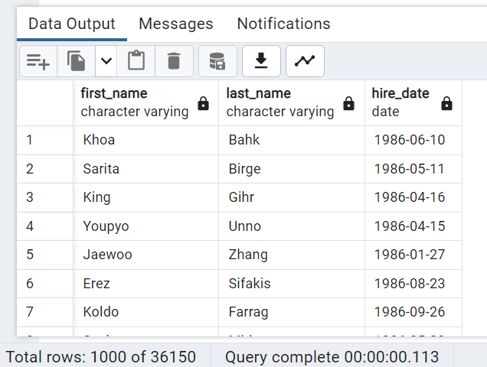

Three

SELECT DM.dept_no, E.emp_no, E.last_name, E.first_name, D.dept_name

FROM dept_manager DM

JOIN employees E

ON DM.emp_no = E.emp_no

JOIN departments D

ON DM.dept_no = D.dept_no

order by dept_no, emp_no asc;

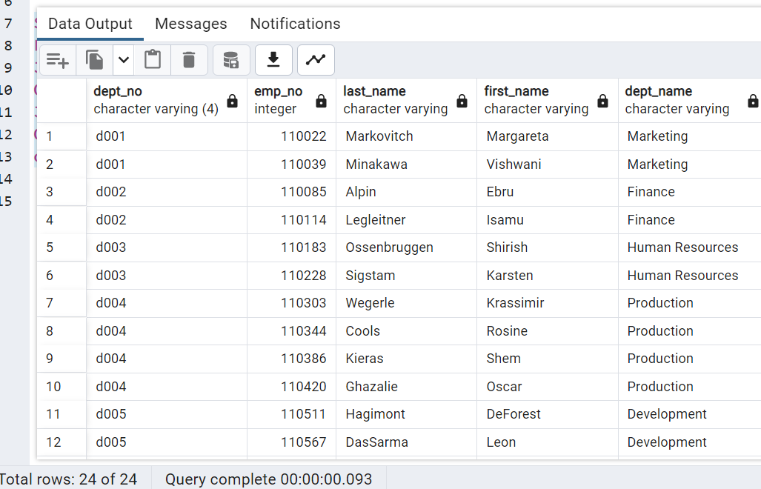

Four

Select DE.emp_no, DE.dept_no, E.last_name, E.first_name, D.dept_name

FROM Dept_Emp DE

JOIN employees E

ON DE.emp_no = E.emp_no

JOIN Departments D

ON DE.dept_no = D.dept_no

order by DE.emp_no asc

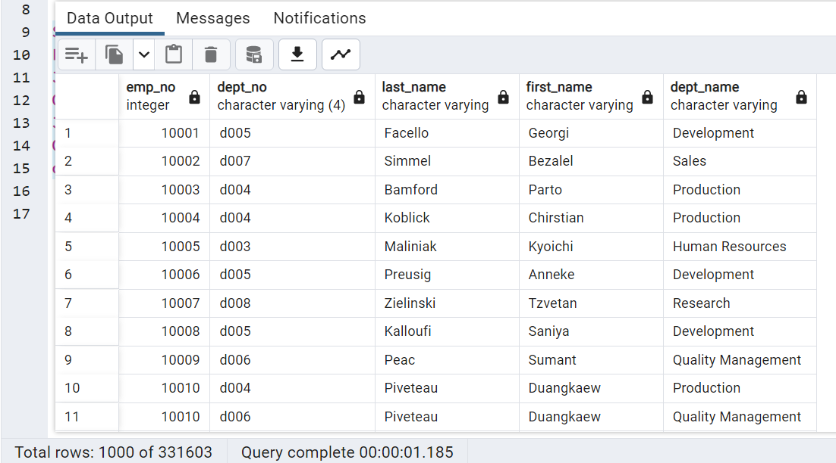

Five

Select first_name, last_name, sex

FROM employees

WHERE first_name = 'Hercules'

and last_name like 'B%'

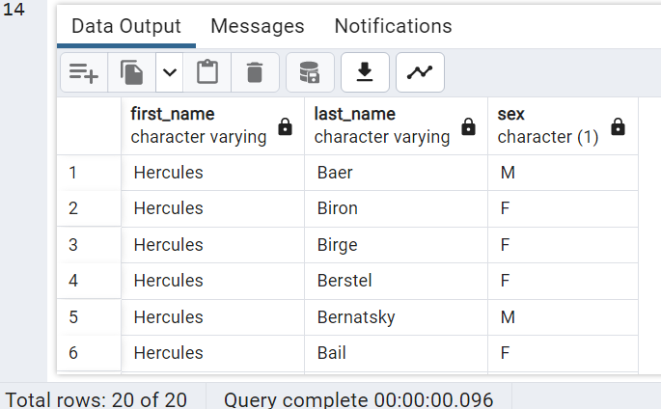

Six

Select DE.emp_no, E.last_name, E.first_name

From Dept_Emp DE

JOIN employees E

ON DE.emp_no = E.emp_no

JOIN Departments D

ON DE.dept_no = D.dept_no

WHERE D.dept_name = 'Sales'

order by emp_no asc

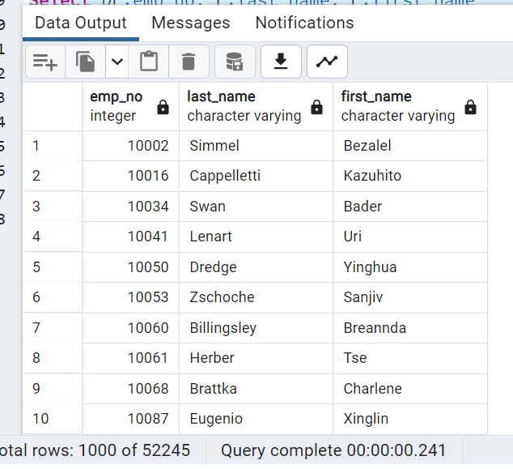

Seven

Select DE.emp_no, E.last_name, E.first_name, D.dept_name

From Dept_Emp DE

JOIN employees E

ON DE.emp_no = E.emp_no

JOIN Departments D

ON DE.dept_no = D.dept_no

WHERE D.dept_name IN ('Sales','Development')

order by emp_no asc

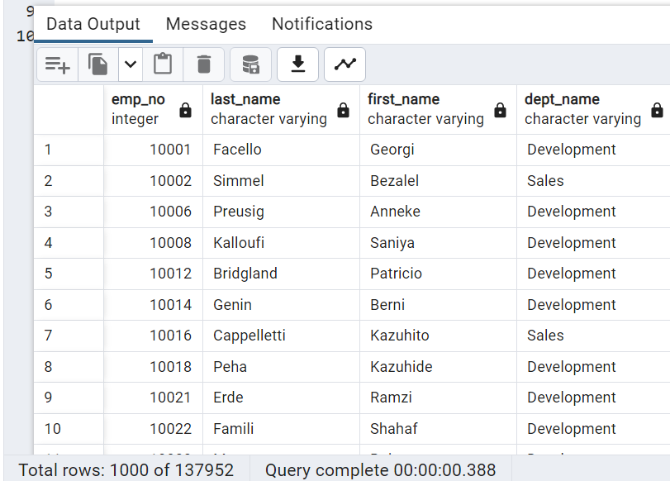

Eight

Select last_name, count(*) AS last_name_count

FROM Employees

GROUP BY last_name

Order By last_name_count desc

